**Batch information:**

* **Batch Start Date: 2025-08-04**
* **Batch Name: WiproNGA_DWS_B5_25VID2550**
* **First Name: Seetal**
* **Last Name: Biswal**
* **User Id: 34933**
* **Batch ID: 25VID2550**
* **Assignment Name- Deploy an App Using PSAppDeployToolKit**

**1.Download the PSAppDeployKit**

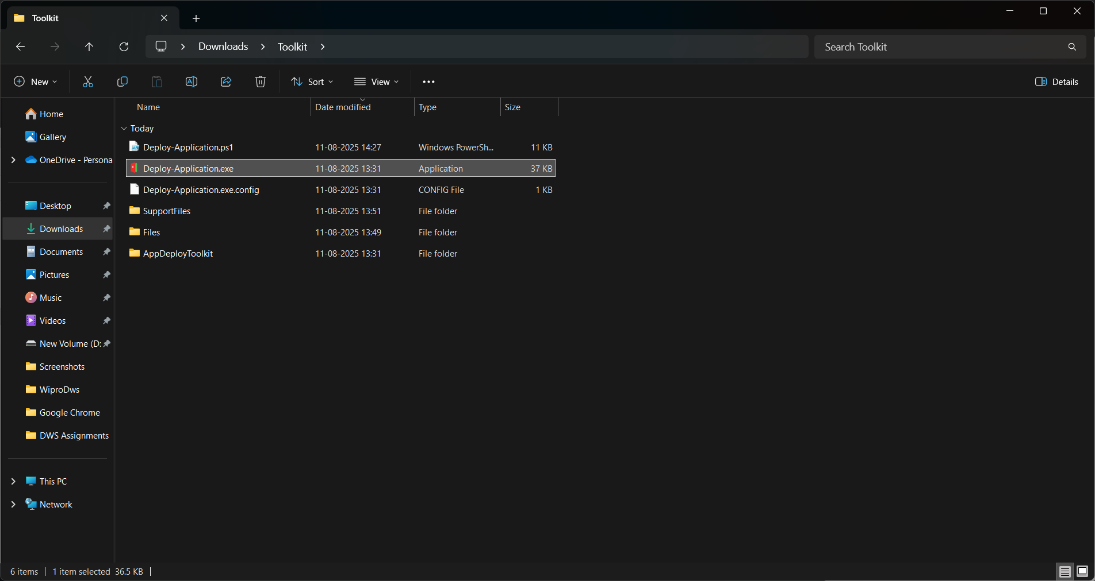

**2. Open the Deploy-Application.ps1 file then in the variable declaration input some important information such as application vendor, name, version, etc.**

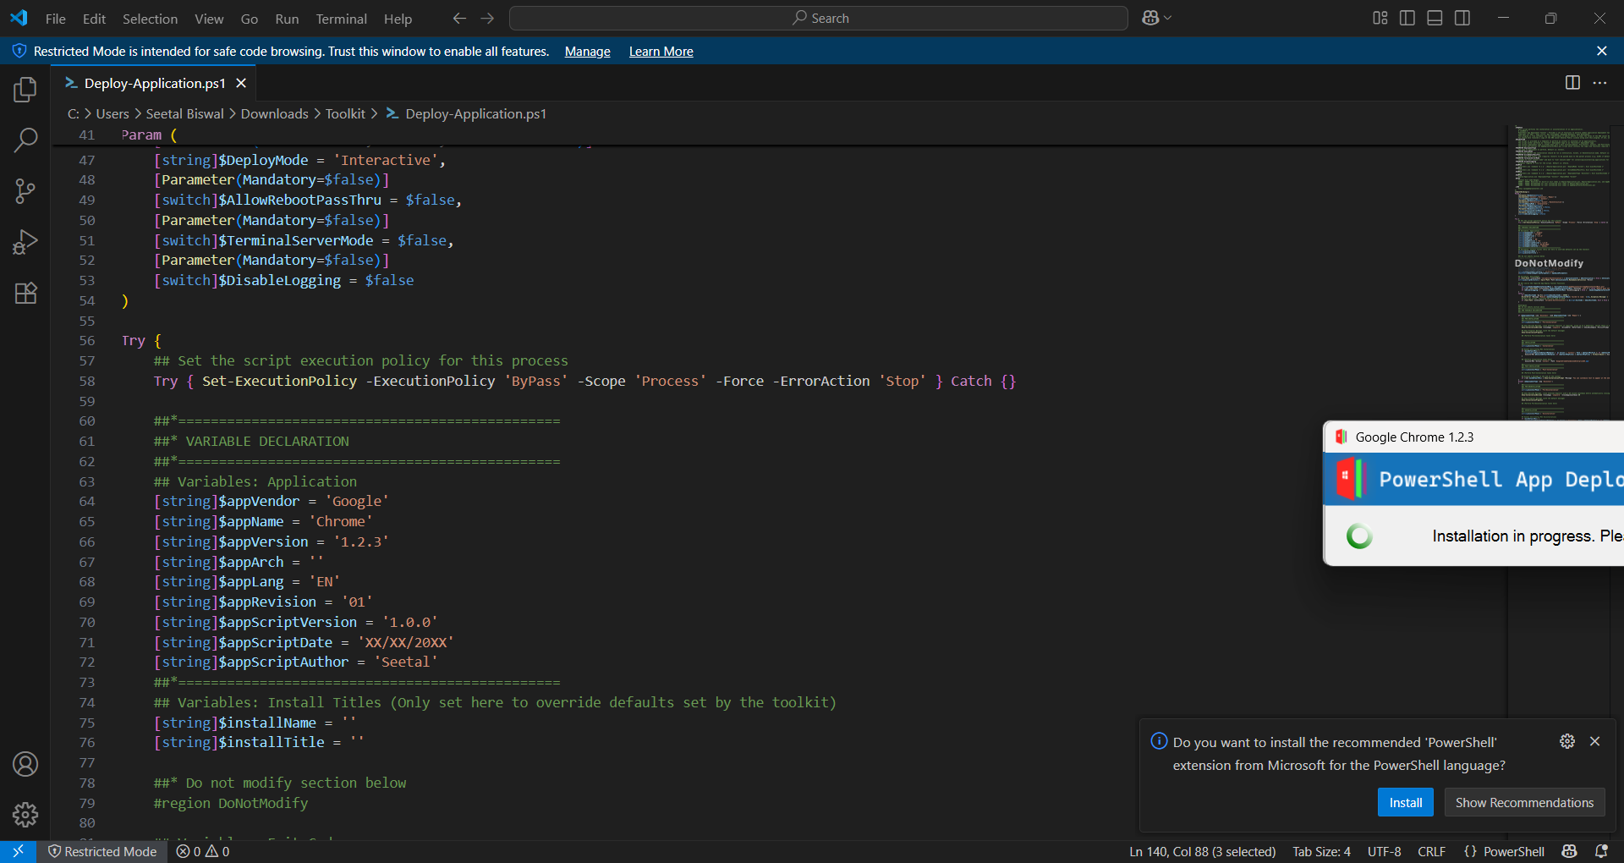

**3. Then scroll down until the Installation part then input the installation code there.**

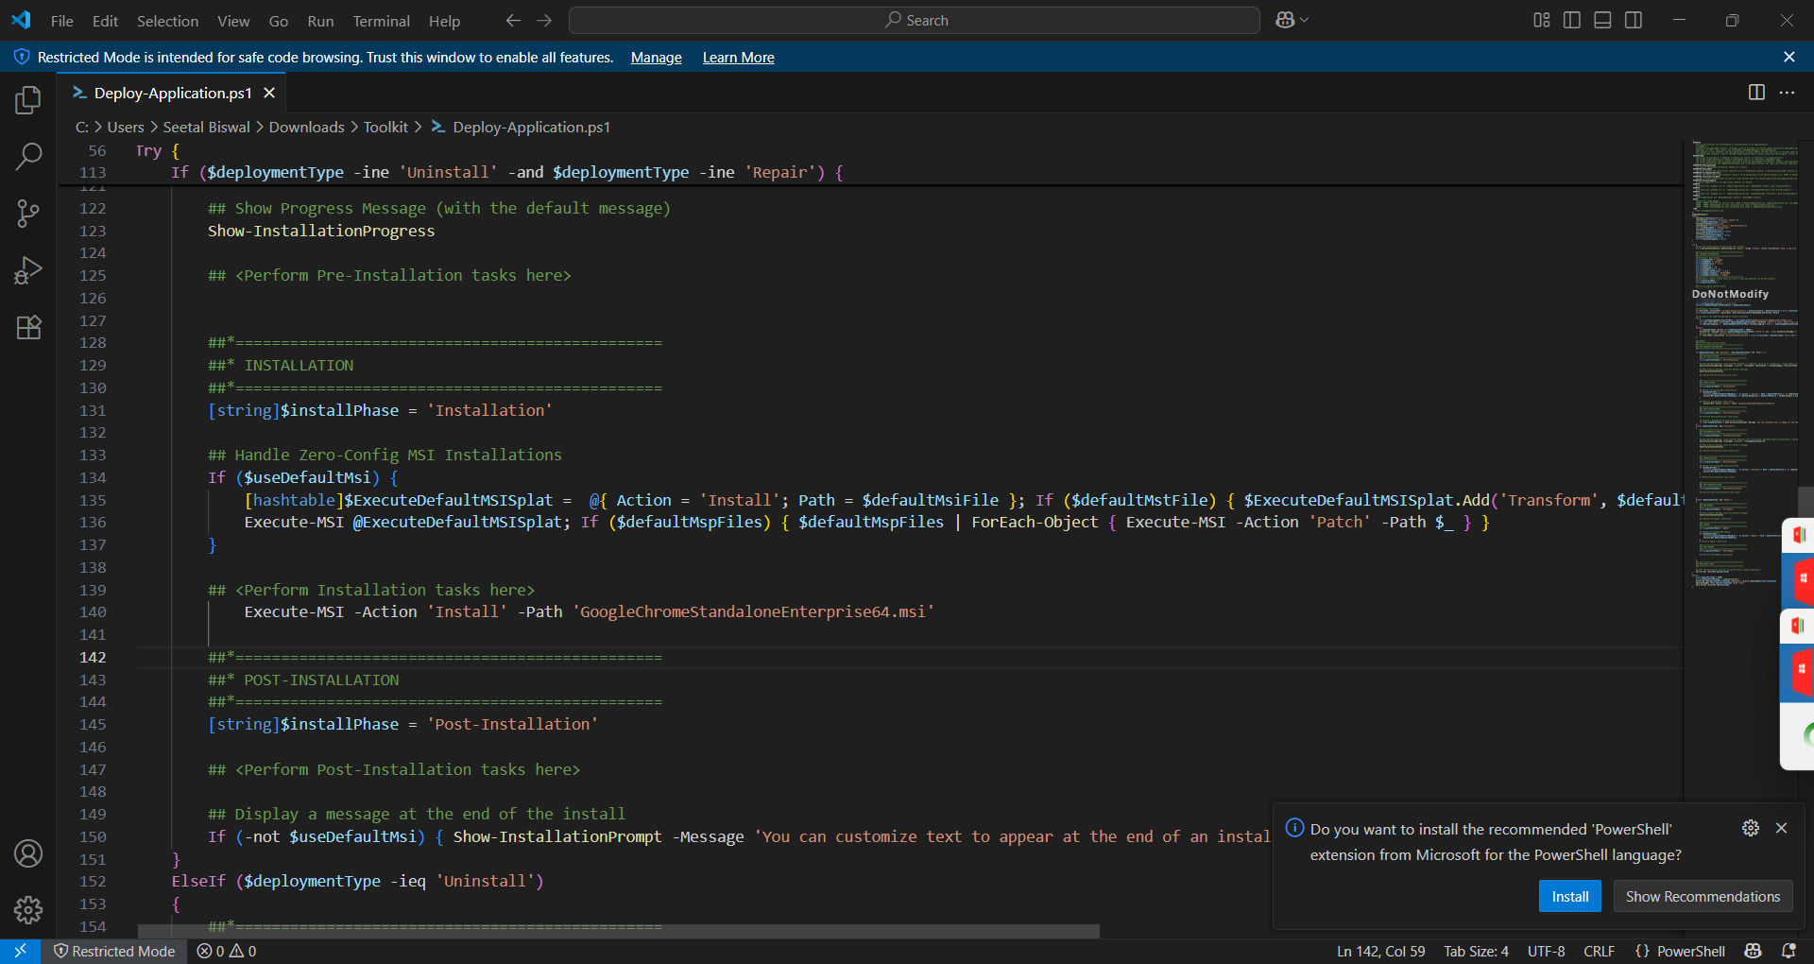

**4. Then run the Deploy Application.exe and then installation will begin.**

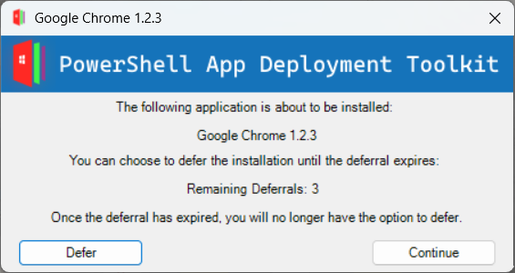

**4.Installation is in progress**

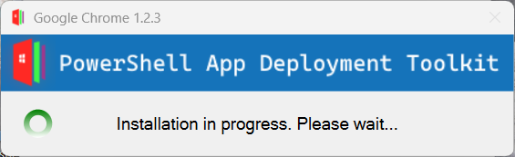

**5.Installation Done.**

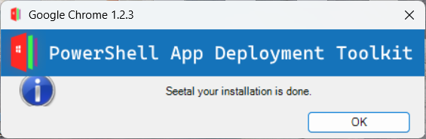

**Uninstall: For uninstall we have to go to the uninstall part of the DeployApptication.ps1 then enter the uninstall code in the ‘perform uninstall task here’ part.**

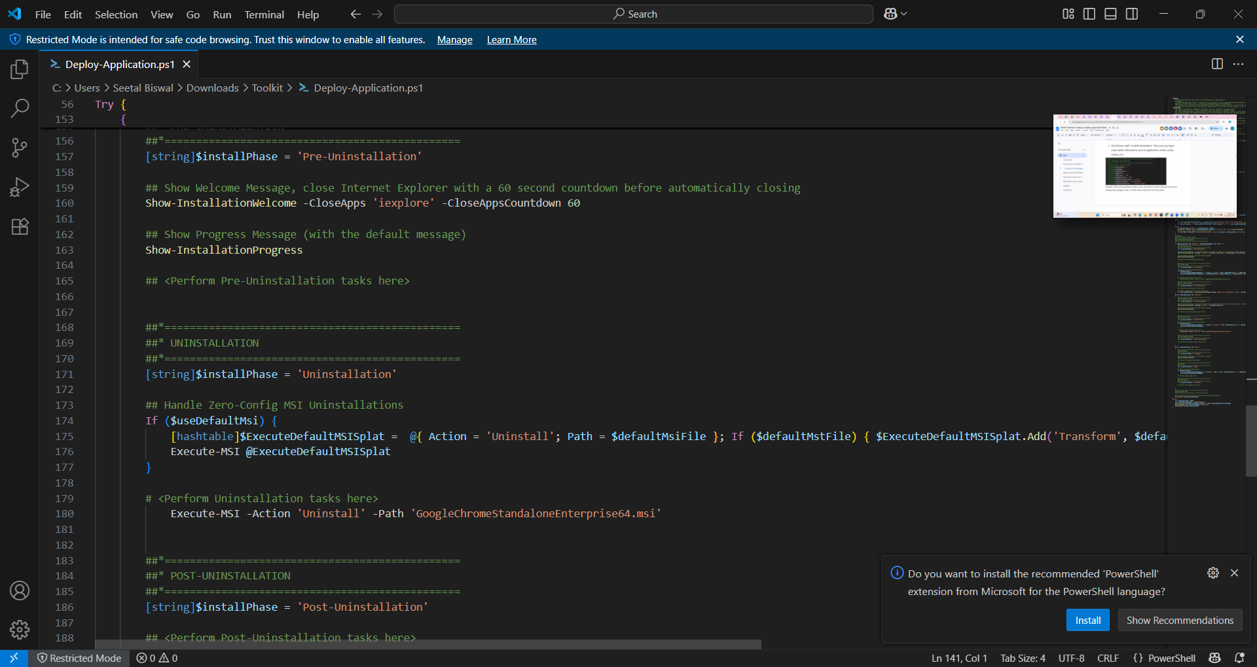

**Then the app will be uninstalled.**